
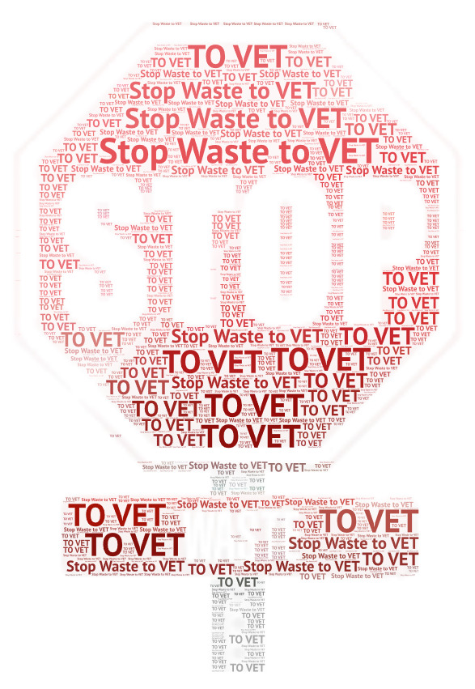

REDUCING FOOD WASTE ALONG THE ENTIRE FOOD SUPPLY CHAIN

Filomena Conforti¹, Mariangela Marrelli¹, Fedora Grande¹, Giancarlo Statti¹
¹University of Calabria, Department of Pharmacy, Health and Nutritional Sciences,
Via Pietro Bucci, 87036, Rende (CS), Italy
email: filomena.conforti@unical.it

Reduction of food losses and waste is a key factor to increase the sustainability of the agri-food sector alongside optimization of the production processes and adoption of a healthy and sustainable diet. The World Resource Institute reported that food loss and waste was estimated to be one-third of the edible food [1]. In this context, reducing food waste along the entire food supply chain is an important policy priority included in the Sustainable Development Goals for 2030 agenda.
The geographical area and level of development of countries have a differential influence on where food is wasted along with the food supply chain. For a unitary approach, one must start from the unitary definition of all the terms that will appear in this circuit.
In Italy food waste means "the set of products discarded from the agri-food chain, which for economic, aesthetic reasons or due to the proximity of the consumption deadline, although still edible and therefore potentially intended for human consumption, are destined to be eliminated or disposed of".
The Waste Resources Action Program (WRAP) proposes a definition of food waste that distinguishes food waste into:
- avoidable (food and drinks that end up in the trash but are still edible, such as pieces of bread, apples, meat, etc.);
- possibly avoidable (food and drink that some people consume, for example bread crusts, and some people do not; but also food that can be consumed if cooked, for example potato peeling);
- unavoidable (meat bones, egg peels, pineapple peels, etc.) [2].
An essential aspect to design efficient and effective policies to reduce food waste along the food supply chain is to know how much and where the food is being wasted.
In high-income regions households and catering sectors are the most impactful, while in low-income areas, food losses are the consequences of non-efficient products’ management and storage [3]. In the European Union food waste accounting is still at an early stage of development and a consolidated framework for food waste quantification is still an open challenge.
Caldeira et al [4] reported that the food groups presenting the highest amount of food waste (considering the total food waste generated in all the supply chain stages) are fruit and vegetables because they are produced and consumed in higher quantities but there are some exceptions: for example, fruit, vegetables, and cereals present similar amounts entering the food supply chain but the food waste of cereals is almost half of the fruit and vegetable food waste. This is due to the higher share of inedible parts in these products and also to the higher perishability of fruit and vegetables compared to some cereal-based products (e.g. pasta and rice).
For cereals and vegetables, the consumption stage is responsible for the largest share of food waste generation. Distribution and retail is the stage with the lowest share of food waste for all food groups.
The development of more sustainable alternatives to reverse the present food system scenario is the general objective of the project Erasmus+ program Key Action 2 in collaboration with international partner universities and enterprises from Romania and Estonia.

References
- Flanagan, K.; Robertson, K.; Hanson, C. Reducing Food Loss and Waste. Setting the Global Action Agenda. 2019. Available online: https://library.wur.nl/WebQuery/wurpubs/553268
- https://www.sprecozero.it/waste-watcher/
- Aureli, V., Scalvedi, M. L., & Rossi, L. (2021). Food waste of italian families: proportion in quantity and monetary value of food purchases. Foods, 10(8), 1920.
- Caldeira, C., De Laurentiis, V., Corrado, S., van Holsteijn, F., & Sala, S. (2019). Quantification of food waste per product group along the food supply chain in the European Union: A mass flow analysis. Resources, Conservation and Recycling, 149, 479-488.

Material created within the ERASMUS KA2 project: 2021-1-RO01-KA220-VET-000028008, "Methods to reduce food waste in flour products by developing the specific competence of specialists in the sector” – STOP WASTE TO VET, 2022 –2024. Key Action 2: cooperation Partnership in vocational education and training.

